**Real-Time Email Alerts from Google Sheets**

**1. Objective: -**

The objective of this project is to create a Python bot that monitors a Google Sheet in real time and sends automated email notifications whenever a row is added or removed. It ensures instant updates via Gmail, ideal for tracking registrations, submissions, or logs without human intervention.

**2. Tools & Technologies: -**

* Python
* Pandas
* smtplib + email.mime
* Threading
* Google Sheets (CSV link)
* Jupyter Notebook

**Step 1: Import Required Libraries**

* Click Run to import all required modules.

**Step 2: Set Up Google Sheet and Email Credentials**

* Replace placeholders with your actual values and Run to initialize configuration.

**Step 3: Define Function to Send Email**

* Run this cell to create the function that sends alert emails.

**Step 4: Define Function to Read Sheet**

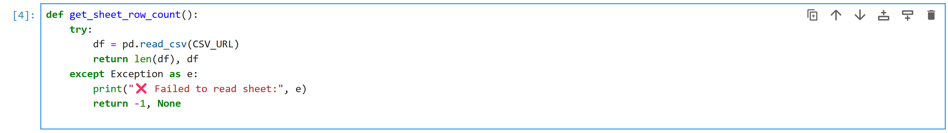

* Run this to read row count from Google Sheet and return data.

**Step 5: Create and Run Monitoring Loop**

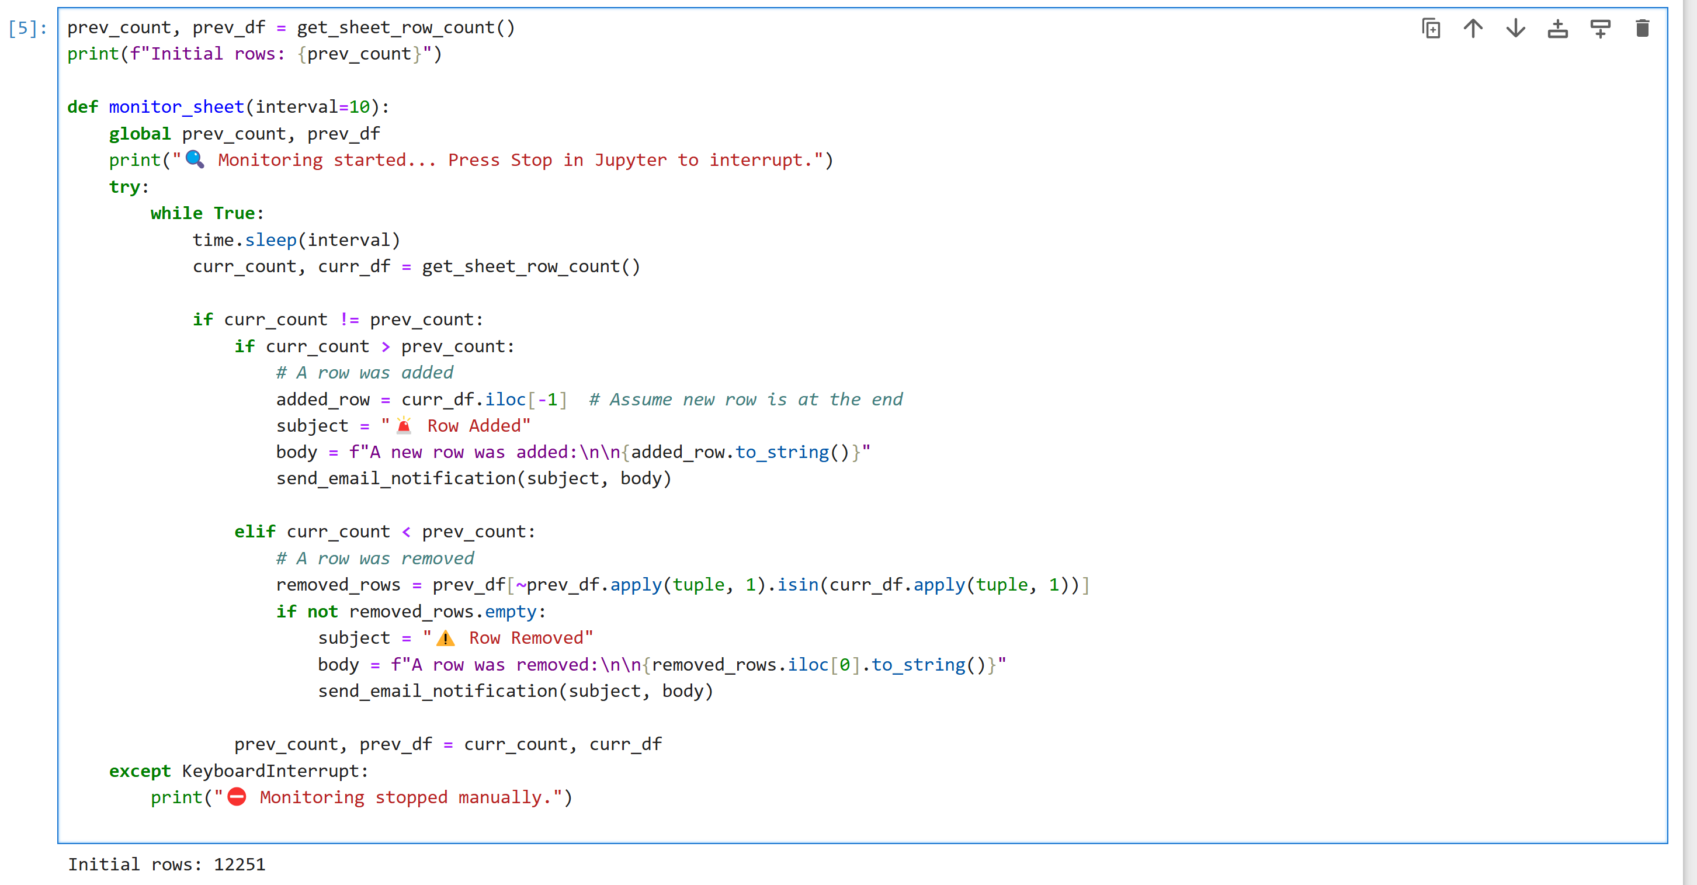

* Run this cell to define the continuous monitoring logic. It checks the sheet every 10 seconds.
* If a new row is added, it sends an email with the new row data.
* If a row is removed, it sends a separate alert.

**Step 6: Start the Monitoring in Background**



* Run this to launch the monitoring in a background thread.
* You will see:



* Email notification received when a row is removed from the Google Sheet.



